Mike Dickson – Orbis  An album containing several improvisations, some offcuts, film music, an organ extravaganza and a lengthy exploration on modular monotony. It also features the last kickings from the remains of Systems Theory and a number of shorter pieces, plus a lingering memory for a friend.  Definitely the last in the series for a while.  Instruments  Pianos, Mellotron, Moogs, synthetic choirs, Celesta, voice synthesisers, assorted percussion, field recordings, voices, and sound effects. All sounds treated, distorted, processed, programmed and reprogrammed widely and according to just how I felt at the time.  See http://www.mikedickson.org.uk/orbis for more information and track notes | Mike Dickson    Orbis
   | © 2011, Black Cat Music Factory  Catalogue Number BCMF30112011  This music is free and must not be sold.

Mike Dickson – Orbis BCMF30112011 |  | Mike Dickson  Orbis  Widor Symphony Number 5 [6:00]  In The Platinum Room [6:50]  Candyman [3:09]  Aglaopheme [1:48]  Hyperbola [2:42]  Lost Nation (Dreamtime) [9:16]  Lickerish [11:27]  Scarborough Fair (Canticle) [3:23]  Shenandoah [3:45]  Rooms [25:57]  © 2011, Black Cat Music Factory |  |  | Mike Dickson – Orbis BCMF30112011
 | 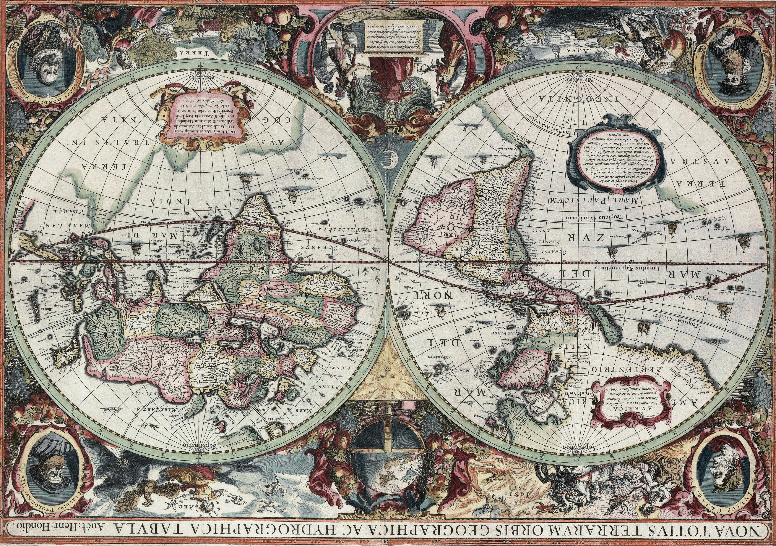 |  |  | Orbis

